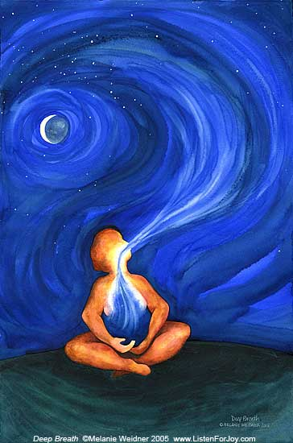 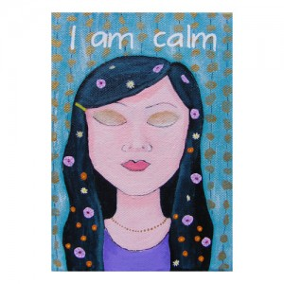

**Take 3 Deep breaths Say “Calm Down” 5 Times**



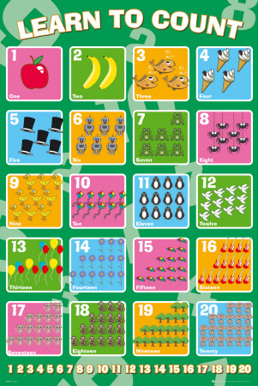

**Count to 20 slowly Flex your muscles—**

**Now Relax. Do this 3 times.**

C:\Users\user\AppData\Local\Microsoft\Windows\Temporary Internet Files\Content.IE5\5CO0RH0J\MC900383564[1].wmf

**Move to a place to calm down Walk away if sad or mad**

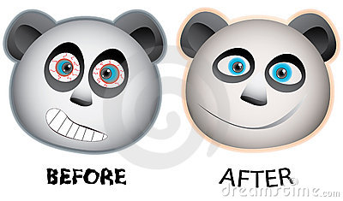

I NEED TO CALM DOWN!!! I DID IT! HOORAY!



I NEED TO CALM DOWN!!! I DID IT! HOORAY!