I Need a ‘Breather’ I Need to Calm Down

- Count backwards 1. Count backwards
SLOWLY from 10. SLOWLY from 10.
2. Take 3 deep breaths. 2. Take 3 deep breaths.
3. Think of a place that 3. Think of a place that
calms you. calms you.
4. Think about what made 4. Think about what
you mad- what can you made you mad -what
do now? can you do now?
5. Return to your seat. 5. Return to your seat.

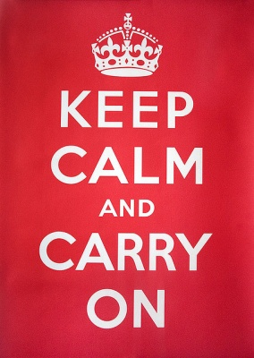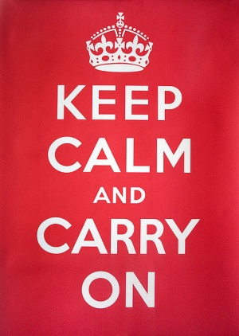

I Need a ‘Breather’ I Need to Calm Down

1. Count backwards 1. Count backwards
SLOWLY from 10. SLOWLY from 10.
2. Take 3 deep breaths. 2. Take 3 deep breaths.
3. Think of a place that 3. Think of a place that
calms you. calms you.
4. Think about what made 4. Think about what
you mad- what can you made you mad -what
do now? can you do now?
5. Return to your seat. 5. Return to your seat.

